Write a program to create a text field and a button “Navigate”. When you enter“www.google.com” and press navigate button it should open google page.
File : MainActivity.java
package com.mkyong.android;

import android.app.Activity;
import android.content.Context;
import android.content.Intent;
import android.os.Bundle;
import android.view.View;
import android.view.View.OnClickListener;
import android.widget.Button;
public class MainActivity extends Activity {
private Button button;
public void onCreate(Bundle savedInstanceState) {
final Context context = this;
super.onCreate(savedInstanceState);
setContentView(R.layout.main);

button = (Button) findViewById(R.id.buttonUrl);

button.setOnClickListener(new OnClickListener() {

@Override
public void onClick(View arg0) {
Intent intent = new Intent(context, WebViewActivity.class);
startActivity(intent);
}
});
}
}
File : WebViewActivity.java
package com.mkyong.android;
import android.app.Activity;
import android.os.Bundle;
import android.webkit.WebView;
public class WebViewActivity extends Activity {
private WebView webView;
public void onCreate(Bundle savedInstanceState) {
super.onCreate(savedInstanceState);
setContentView(R.layout.webview);
webView = (WebView) findViewById(R.id.webView1);
webView.getSettings().setJavaScriptEnabled(true);
webView.loadUrl("http://www.google.com");
}}

File : res/layout/main.xml
<?xml version="1.0" encoding="utf-8"?>
<LinearLayout xmlns:android="http://schemas.android.com/apk/res/android"
android:layout_width="fill_parent"
android:layout_height="fill_parent"
android:orientation="vertical" >

<Button
android:id="@+id/buttonUrl"
android:layout_width="wrap_content"
android:layout_height="wrap_content"
android:text="Go to http://www.google.com" />

</LinearLayout>
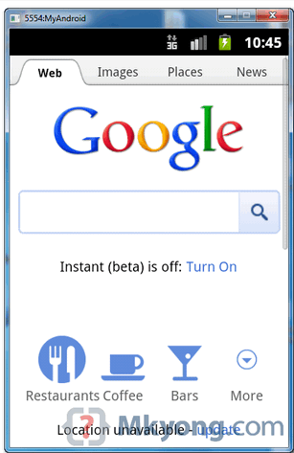
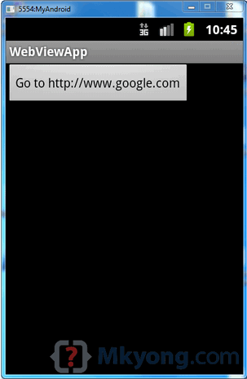
output:-

2. Write a program to create button “Start Dialer”. When u click on this button it should open the phone dialer.

